**Run the code:**

1. In the command prompt, go to the directory where your program is saved in
2. Then write the command to run the python file as follows:

python assignment.py /path

(Path-contains the path of cam folder where all the images are stored)

**Example:**

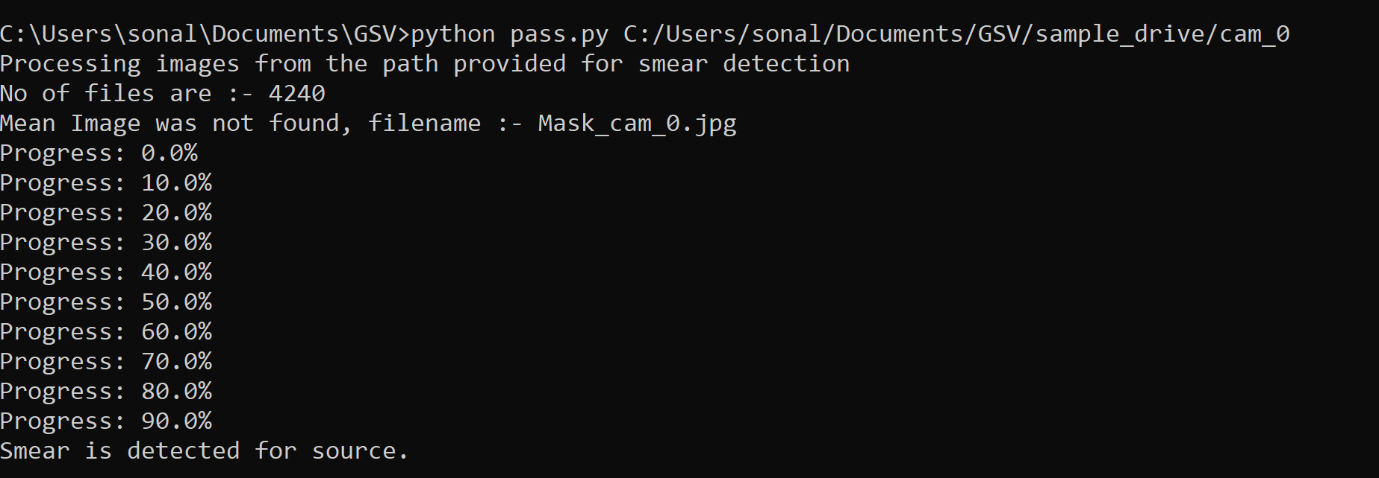

**OUTPUTS**

The outputs for each folder are pasted below:

**CAM_0:**

**Step 1: Input Image**

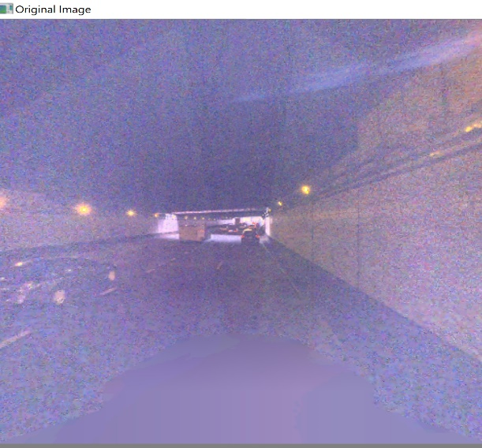

**Step 2: Average Image**

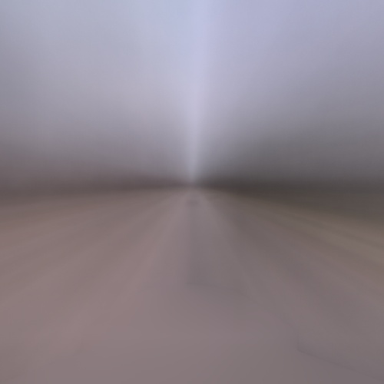

**Step 3: Adaptive Threshold**

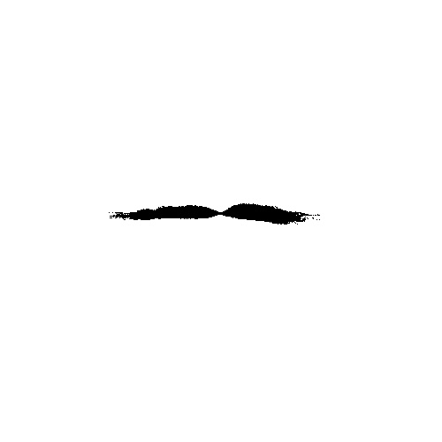

**Step 4: Edge Detection:**

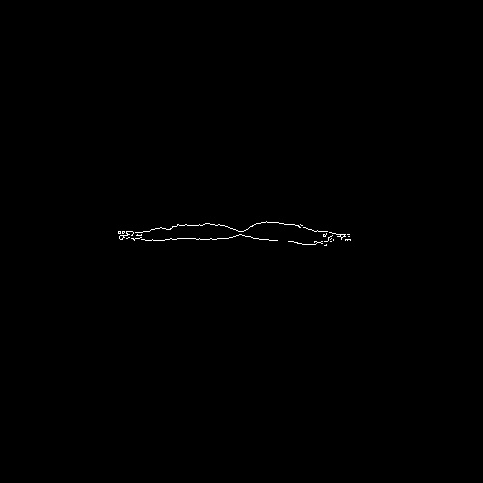

**Step 5 : Final Output**

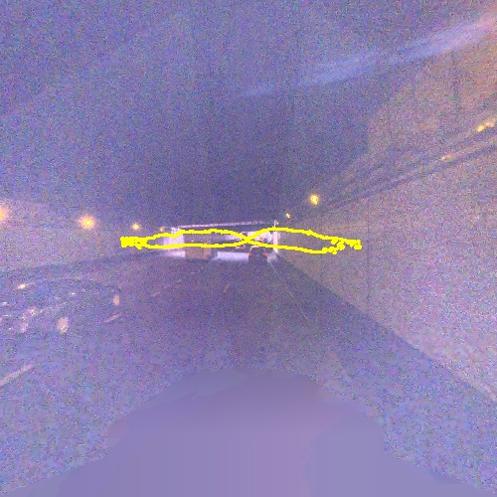

**Step 6 : Progress bar on command prompt**



**CAM_1:**

**Step 1: Input Image**

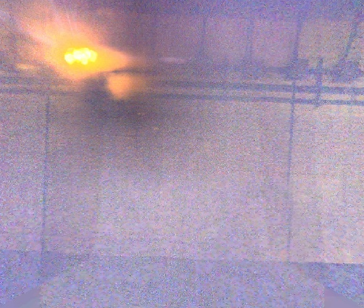

**Step 2: Average Image**

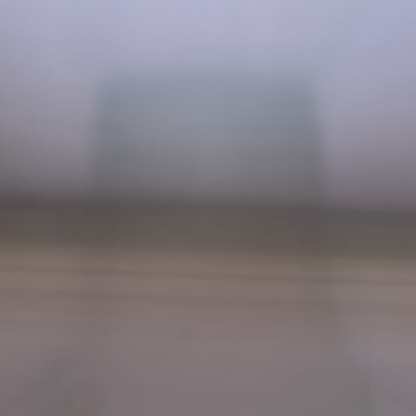

**Step 3: Adaptive Threshold**

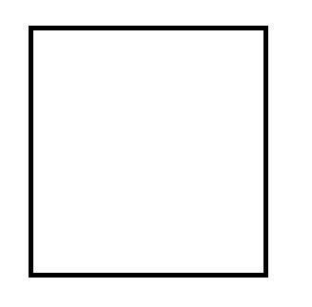

**Step 4: Edge Detection:**

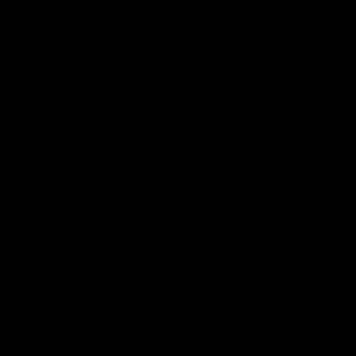

**Step 5: Final Output**

No Smear, so no output

**Step 6 : Progress bar on command prompt**

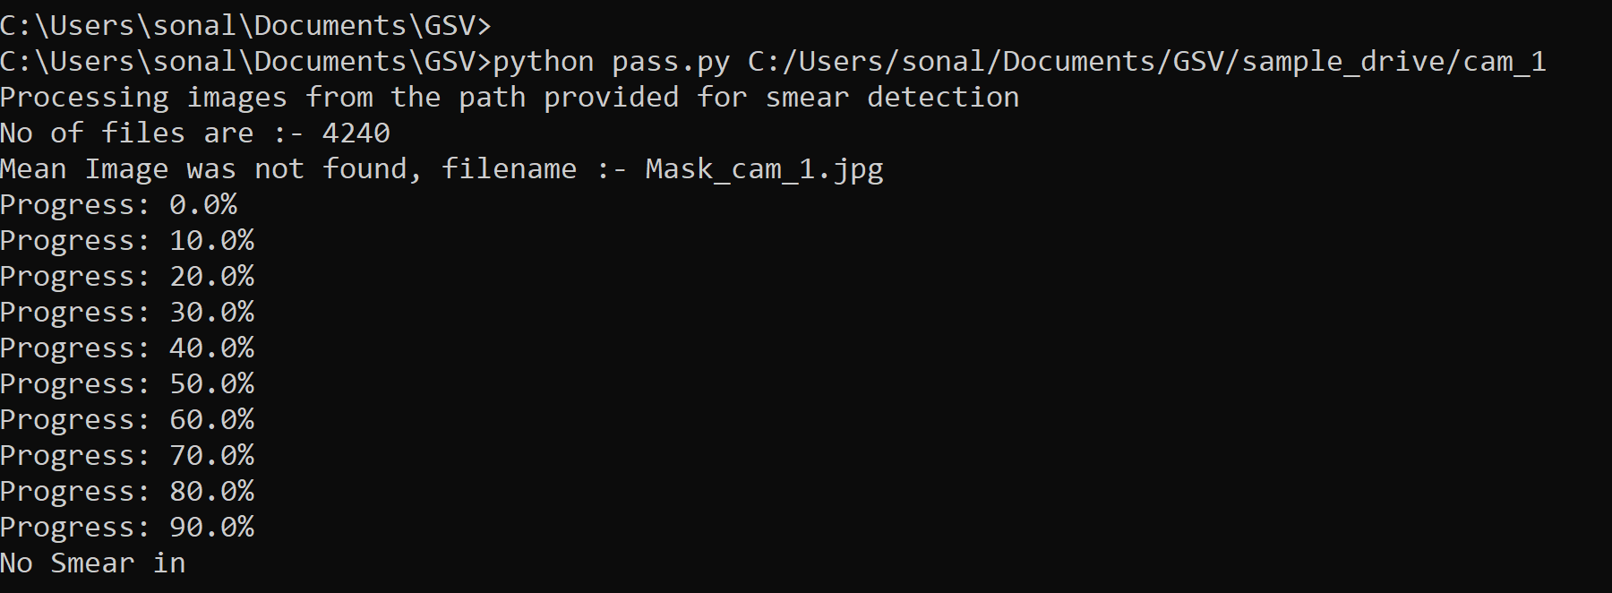

**CAM_2 :**

**Step 1: Input Image**

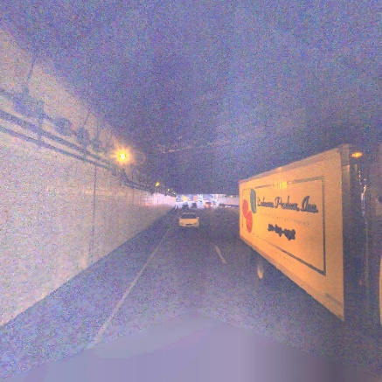

**Step 2: Average Image**

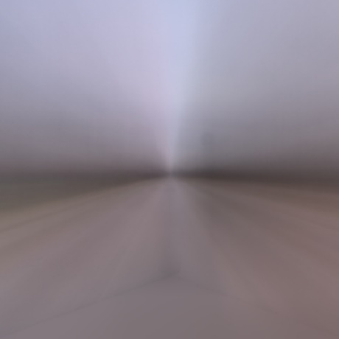

**Step 3: Adaptive Threshold**

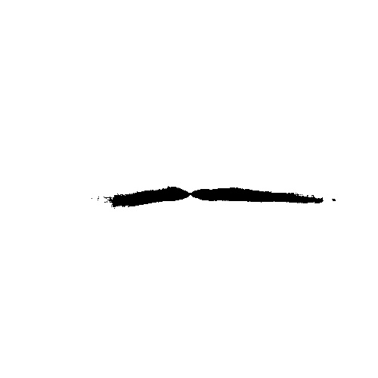

**Step 4: Edge Detection:**

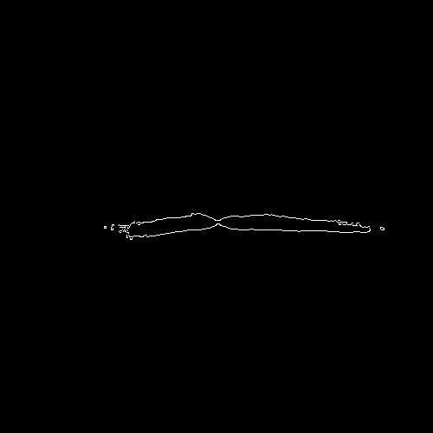

**Step 5: Final Output**

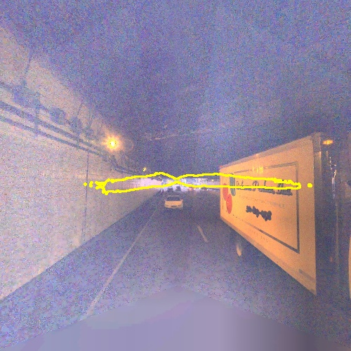

**Step 6 : Progress bar on command prompt**

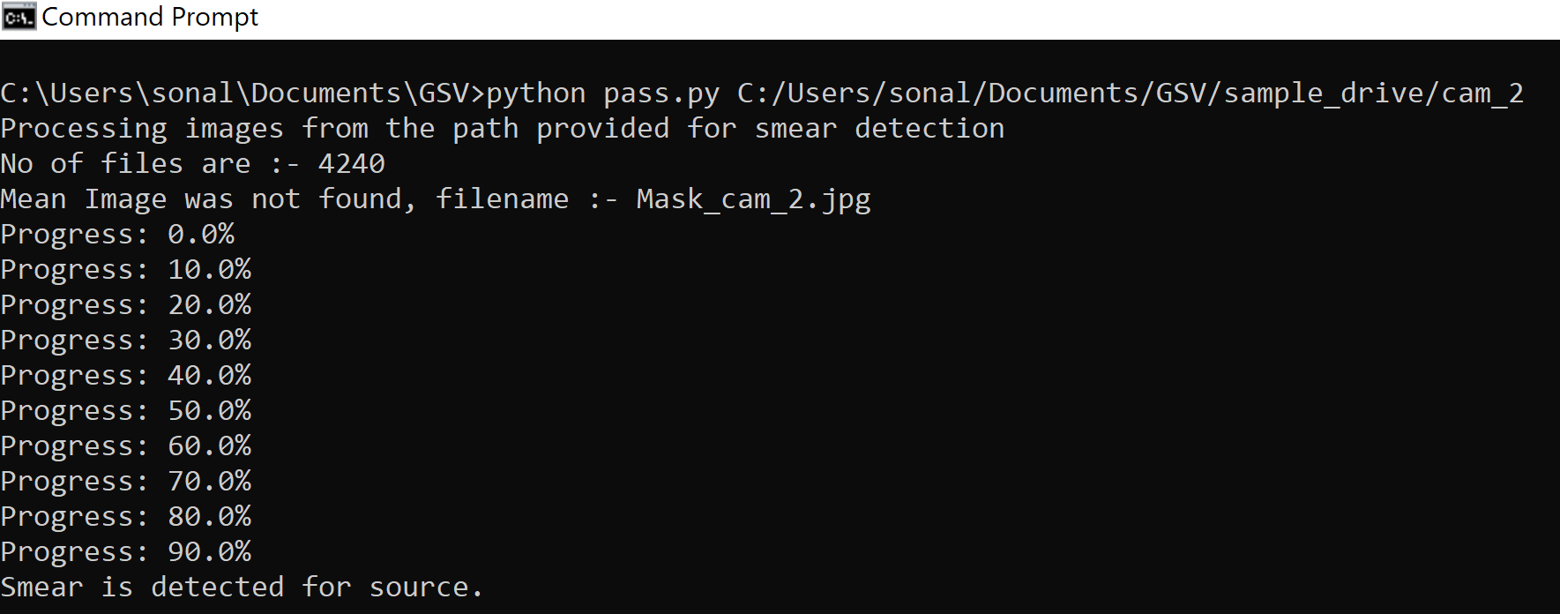

**CAM_3:**

**Step 1: Input Image**

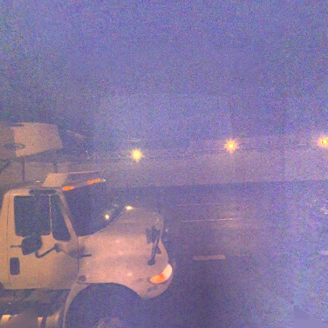

**Step 2: Average Image**

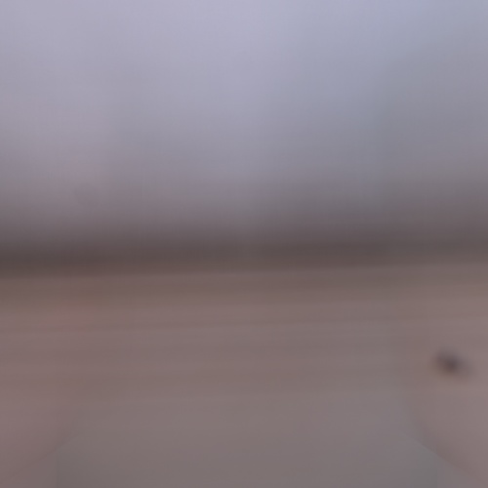

**Step 3: Adaptive Threshold**

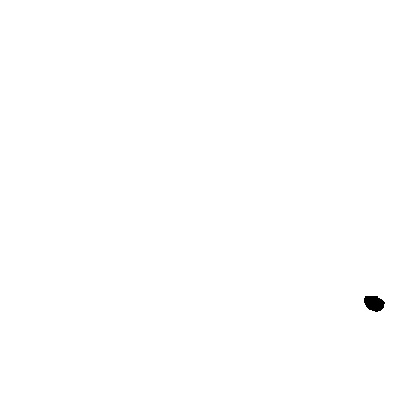

**Step 4: Edge Detection:**

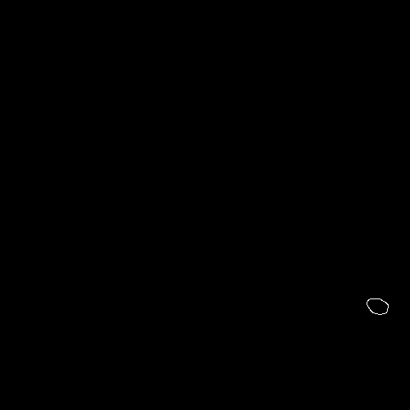

**Step 5: Final Output**

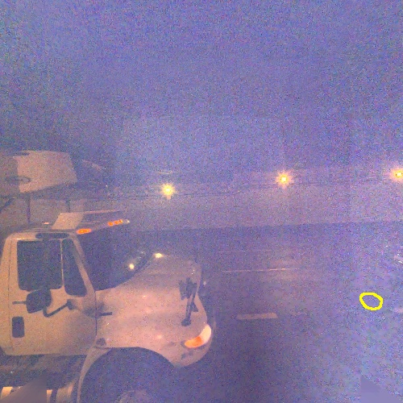

**Step 6 : Progress bar on command prompt**

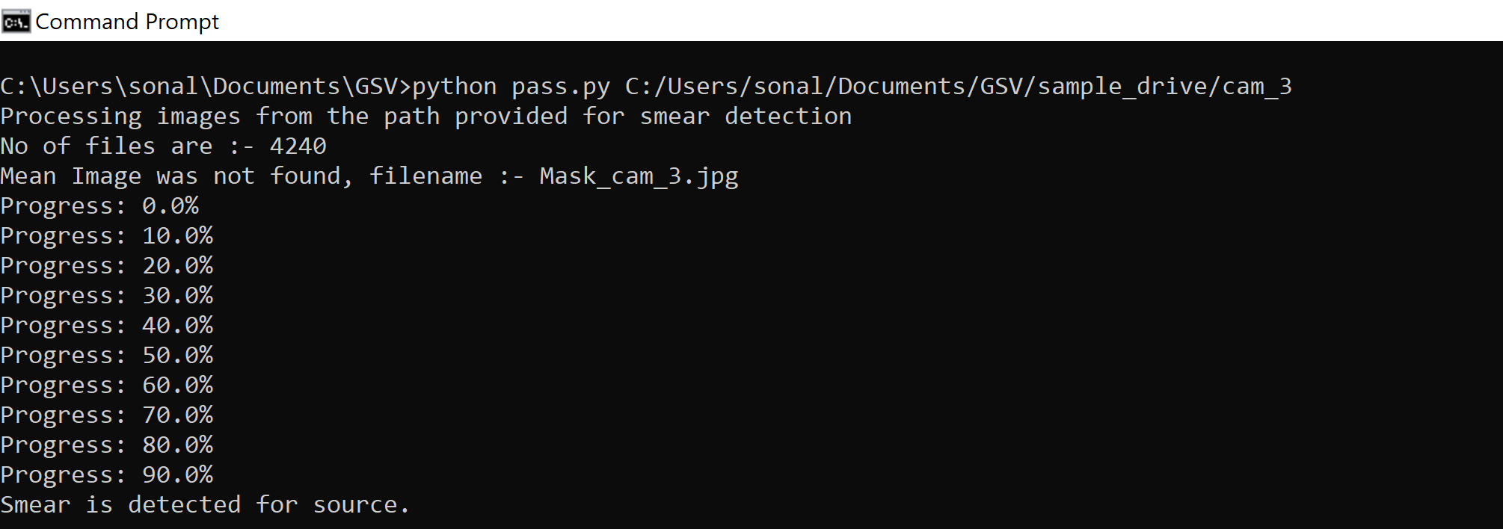

**CAM_5 :**

**Step 1: Input Image**

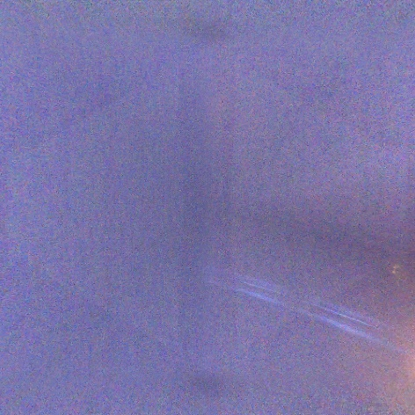

**Step 2: Average Image**

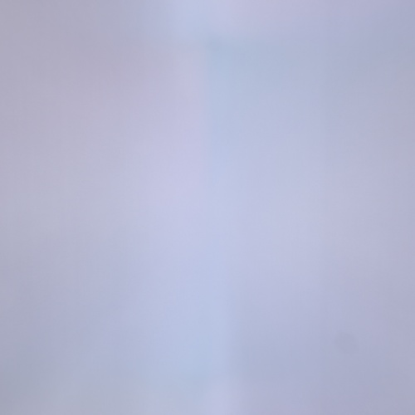

**Step 3: Adaptive Threshold**



**Step 4: Edge Detection:**

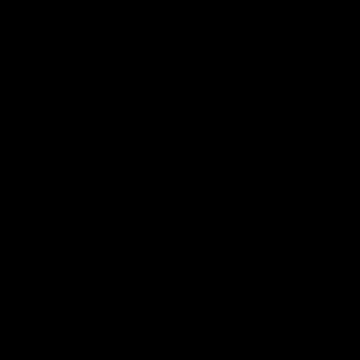

**Step 5: Final Output**

No Smear, so no output

**Step 6 : Progress bar on command prompt**

